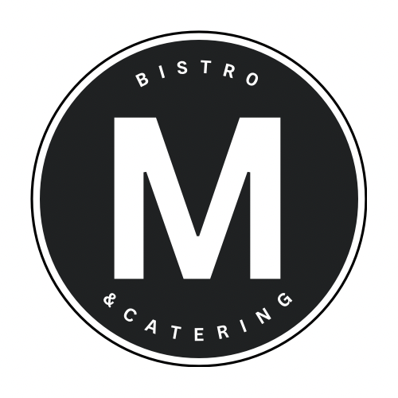
A local fresh food experience
_____________________________________________________________________________________________________________________________________

Beginning
-Charcuterie for TWO
A selection of premium cured meats and artisanal cheeses complemented by a medley of
seasonal fruits, nuts, olives, and artisanal crackers 33

-Bang Bang Shrimp
Plump, succulent Shrimp tossed in our irresistible spicy, creamy sauce 24

-Tomato Basil & Fresh Mozzarella Salad
Drizzled with a delicate Balsamic glaze and extra virgin Olive Oil 18

-Seafood Antipasto 19

Main
Mains are accompanied by Chef Choice of starch and vegetables from the current season, where not specified.

-AAA Grilled beef TENDERLOIN /6 oz
With Peppercorn Sauce 59
-LOBSTER Tail
Charred with Herb-Honey Butter 59
-CHICKEN Penne Alfredo
All-natural chicken supreme in a velvety Alfredo sauce
Choice of Béarnaise sauce, charred with Herb Butter, Maple glazed or Barbecue 38
-B.C SALMON Risotto
Tender Salmon atop creamy Arborio rice, in a Tomato-Ginger broth 52
-PORK Wellington
Pork tenderloin wrapped in prosciutto, enveloped in flaky puff pastry 39
Add to your main
Lobster Tail 4-5 oz served honey butter +28 /Pan-seared Gulf Shrimp Lemon Garlic herb butter +18
/Pan-seared Scallops White Wine Lemon +17 / Chicken +9

Dessert
Toasted Almond Maringue for two 23
Black & white Chocolate Mousse 20
Crème Brûlée 15
Strawberry Devils Cake for two 19
Piquito Freddo - double Chocolate dome (gluten free) 20

Please ask about our Vegetarian and Gluten free options
4086 Erie Road, Crystal Beach ON L0S 1B0 Tel 289-808-9349 mbistrocatering.ca
Gift Cards Available – Give the gift of great food!

_____________________________________________________________________________________________________________________________________
About Us
We are a locally owned and Operated restaurant
using Ontario farmers to create a Locally sourced,
fresh food Canadian experience for all the senses.
Led by Chef George's more than 35 years of experience,
unique style and diverse culinary background;
we strive to be a very memorable part of your stay in
Crystal Beach, Ontario, The South Coast of Canada!!
Featuring Fresh food, Great Wine & Attentive and Friendly Service.

Food isn’t just what we eat.
It’s what brings us together
as families and communities.
Enjoy!
-Chef George

4086 Erie Road, Crystal Beach ON L0S 1B0 Tel 289-808-9349 follow Us @mbistro.cb

